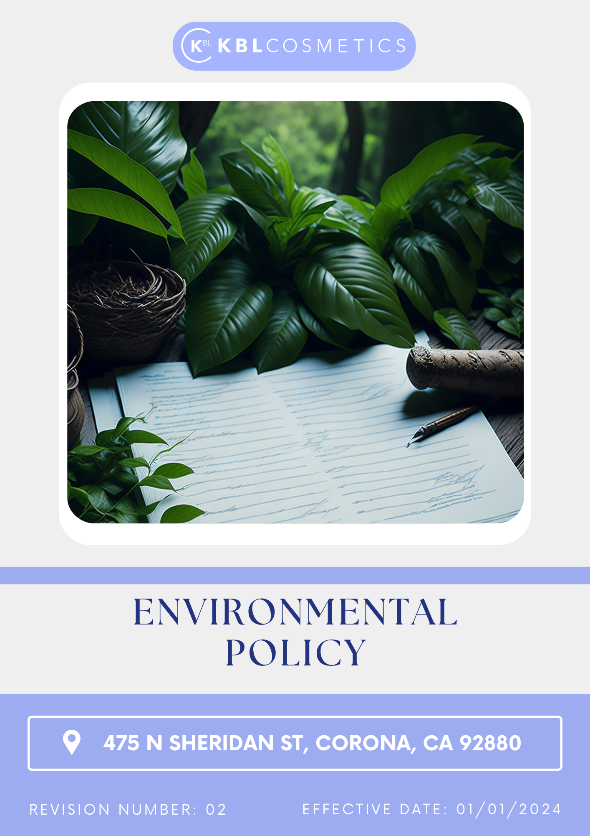

Table Of Contents

1. Introduction 3
2. The Arminak Solutions LLC dba KBL Cosmetics Approach 3
3. Scope 3
4. What's Expected 3
5. Journey to Sustainability: An Arminak Solutions LLC dba KBL Cosmetics Commitment: 4
6. Responsibility 7
7. Reporting Section 8
8. Covered SDGs 9
9. Review Mechanism 9
10. Employee Acknowledgement Form: Environmental Policy 10

Introduction
Arminak Solutions LLC dba KBL Cosmetics is dedicated to ethical business operations and environmental sustainability. We are committed to lowering our carbon footprint, protecting natural resources, and advancing sustainable development because, as a business in the beauty and personal care sector, we understand the potential environmental impact of our activities.

The Arminak Solutions LLC dba KBL Cosmetics Approach
Arminak Solutions LLC dba KBL Cosmetics is committed to designing, manufacturing, and delivering high-quality cosmetic products while operating in a manner that protects the environment and promotes the sustainable use of natural resources. Our approach includes responsible sourcing of ingredients, water conservation, efficient use of raw materials, waste reduction, and clean energy utilization, while fostering sustainability across our entire value chain.

We set annual environmental goals, develop the necessary capabilities, and allocate appropriate resources to achieve this policy through innovation, operational efficiency, and ensuring our supply chain aligns with our sustainability commitments.

Scope
This policy applies to all employees, stakeholders, contractors, partners, customers, contractual workers, and anyone acting on behalf of following sites:

 | ARMINAK SOLUTIONS LLC DBA KBL COSMETICS
 | Address: 475 N Sheridan St, Corona, CA 92880
 | https://kblcosmetics.com/

What's Expected
- Environmental Compliance
At Arminak Solutions LLC dba KBL Cosmetics, we are committed to adhering to all applicable environmental laws and regulations. We engage our employees, establish performance standards, and implement an Environmental Management System to ensure compliance and foster continuous improvement. Our initiatives include:
Ethical Ingredient Sourcing: We prioritize the use of ethically sourced, organic, and sustainable ingredients in our products, ensuring they are free from harsh chemicals and toxins.
Water Conservation: We implement measures to reduce water usage and promote recycling within our operations.
Energy Efficiency: We invest in energy-efficient technologies and waste reduction measures to minimize our environmental footprint.
Waste Reduction: We minimize waste generation and promote recycling throughout our operations and supply chain.
Sustainable Packaging: We choose eco-friendly packaging options, such as recycled materials and biodegradable containers, to reduce waste.
Product Development: We develop products with minimal environmental impact during their use phase, including creating biodegradable and compostable products.
Customer Health and Safety: We ensure customer health and safety by adhering to stringent quality control and safety standards.
Sustainable Consumption: We promote sustainable consumption by advocating for environmentally friendly alternatives to synthetic materials.
Product End-of-Life: We promote responsible end-of-life management of products and packaging by supporting reuse, recycling, compost ability, refillable systems, and environmentally responsible disposal practices to reduce landfill waste and encourage circular economy principles.

Journey to Sustainability: An Arminak Solutions LLC dba KBL Cosmetics Commitment:
We're using 2022 as the baseline year to track our sustainability progress.

- Water usage reduction and recycling:
- We implement measures to reduce water consumption in production processes and plan to decrease water usage in production processes by 20% by 2030.
- By 2030, 15% of our product lines to waterless or low-water formulations, reducing reliance on water as a primary ingredient and decreasing the environmental impact of our products.

- Renewable energy and energy efficiency:
- We aim to reduce energy consumption by 15% by 2030 through efficiency improvements and renewable energy adoption.
- We plan to increase the use of renewable energy in operations by 30% by 2030.
- We aim for transition to renewable energy sources, with a goal of sourcing 20% of our energy needs from solar and wind power by 2030, thereby reducing reliance on fossil fuels.

- Greenhouse gas (GHG) reduction:
- We aim to establish science-based GHG reduction targets aligned with the latest climate science to limit global warming to 1.5°C, ensuring that our goals are independently validated and contribute effectively to global climate efforts by 2030.
- We aim to Reduce greenhouse gas emissions Scope 1,2 & 3 by 15% by 2030 compared to baseline 2022 levels.

- Waste minimization and recycling:
- We minimize waste generation through reduction, reuse, and recycling initiatives and want to achieve a 20% reduction in total waste generated by 2030 through recycling and waste minimization efforts.
- We plan to achieve zero landfill waste by 2030 through enhanced recycling and waste-to-energy initiatives.

- Biodiversity support:
- We plan to improve soil health by ensuring that 50% of agricultural raw materials are grown using regenerative farming practices by 2030.
- We intend to support conservation projects to protect at least 5 endangered species affected by ingredient sourcing by 2030.
- We aim to use 50% biodegradable or recyclable packaging for all products by 2030 to prevent plastic pollution in ecosystems.

- Contamination management:
- We aim to eliminate the use of per- and polyfluoroalkyl substances (PFAS) in all products by 2030, in line with proposed EU restrictions due to their environmental persistence and potential health risks.
- We ensure that all water used in production meets stringent microbiological standards, adhering to Good Manufacturing Practices (GMP) to prevent contamination.

- Air pollution reduction:
- We aim for 30% decrease in Volatile Organic Compounds (VOCs) emissions from products such as hairsprays and fragrances by 2030 through reformulation and process improvements.
- We plan to install advanced emission control systems in manufacturing facilities to reduce airborne pollutants, aiming for a 25% reduction in particulate matter emissions by 2030.
- We intend to implement sustainable logistics strategies, including optimizing delivery routes and utilizing low-emission vehicles, to achieve a 15% reduction in transportation-related air pollution by 2030.

- Noise pollution minimization:
- We aim to perform thorough evaluations of noise levels across all manufacturing facilities to identify primary noise sources and establish baseline data for monitoring the effectiveness of noise reduction initiatives by 2030.
- By 2030, introducing engineering solutions such as vibration isolators, silencers, and noise-dampening materials to reduce noise at the source, aiming for a 15% reduction in overall noise levels.
- We intend to equip high-noise machinery with acoustic enclosures and install sound barriers where necessary to contain noise, with the goal of achieving a 15% reduction in noise emissions by 2030.

- Responsible raw material and chemical management:
- Identify and phase out the use of chemicals of concern in product formulations, aiming to eliminate at least 50% of such substances by 2030.
- We aim to develop and implement sustainable chemical and waste management strategies by 2030, focusing on priority chemicals of concern and adopting standards like the chemical footprint approach to reduce their impact along the value chain.
- We intend to reduce plastic packaging waste by 30% by 2030 through the adoption of sustainable materials and designs, contributing to decreased environmental pollution.

- Environmentally friendly product development:
- We aim to ensure that at least 60% of our product formulations are derived from natural, renewable sources, minimizing reliance on synthetic chemicals by 2030.
- We plan to adopt green chemistry methodologies in 30% of our manufacturing processes to reduce environmental impact and enhance product safety by 2030.
- We intend to ensure that 20% of our products are biodegradable, reducing their environmental footprint post-consumer use by 2030.

- Biodegradable and compostable products:
- We aim to ensure that 30% of packaging materials are biodegradable by 2030, aligning with industry trends towards sustainable cosmetic packaging.
- We plan for transition towards 20% of product packaging to compostable materials by 2030, following the industry's shift towards compostable cosmetic packaging.
- We plan to introduce refillable packaging for 20% of product lines by 2030, supporting the move towards sustainable cosmetic packaging solutions.
- We ensure to eliminate single-use plastics in product packaging by 2030, in line with consumer demand for eco-friendly alternatives.

- Customer health and safety:
- We aim to conduct thorough safety evaluations for all products by 2030, ensuring compliance with global cosmetic safety regulations.
- We plan to provide clear and accessible information on all product ingredients, including potential allergens, to empower consumers to make informed choices by 2030.
- We plan to achieve full compliance with GMP guidelines by 2030 to ensure product quality and safety throughout the manufacturing process.

- Promoting sustainable consumption:
- We aim to launch an educational campaign by 2030 to inform consumers about sustainable beauty routines, including the benefits of using eco-friendly products and reducing waste.
- We plan to provide guidelines on product usage to minimize overconsumption and waste, promoting practices such as using appropriate amounts and proper storage to extend product life by 2030.
- We intend to establish a platform for consumers to share their sustainable beauty practices and experiences, creating a community that supports and inspires responsible consumption by 2030.
- Environmental Services and Advocacy
- We aim to join industry-wide initiatives aimed at developing standardized environmental impact assessment and scoring systems for cosmetic products, promoting transparency and sustainability across the sector by 2030.
- We plan to allocate funding to environmental research projects by 2030, focusing on innovative solutions to reduce the ecological footprint of cosmetic products and packaging.
- By 2030, participate in public campaigns to raise awareness about environmental issues related to the cosmetics industry, encouraging consumers and other stakeholders to adopt more sustainable behaviours.
- Product End-of-Life:
- We aim to ensure that at least 50% of product packaging is recyclable, reusable, biodegradable, or compostable by 2030.
- We plan to introduce refillable or reusable packaging solutions for 20% of product lines by 2030 to reduce single-use packaging waste.
- We intend to increase the use of recycled content in packaging materials by 30% by 2030 to support circular material use.
- We aim to assess lifecycle impacts for major product categories by 2030 and integrate circular economy principles into future packaging and product development decisions.
- We plan to collaborate with recycling and waste management partners to improve collection and recovery systems for post-consumer packaging waste by 2030.

Responsibility
- Board of Directors:
- Oversees the overall environmental strategy and approves long-term sustainability goals.
- Ensures alignment of environmental initiatives with business objectives and stakeholder expectations.

- Chief Sustainability Officer (CSO):
- Leads the development and implementation of the Environmental policy across the organization.
- Reports directly to the CEO and provides regular updates to the Board of Directors.

- Senior Management:
- Provides leadership in implementing the Environmental policy within their respective divisions.
- Allocates necessary resources and integrates sustainability metrics into performance evaluations.

- Sustainability Committee:
- A dedicated sustainability committee comprising representatives from various departments is established to oversee the execution of sustainability initiatives.
- The committee is tasked with developing action plans, monitoring performance, and recommending improvements to meet sustainability objectives.

- Departmental Heads:
- Departmental heads are responsible for integrating sustainability practices into their respective areas of operation.
- They ensure compliance with environmental regulations, promote resource efficiency, and support employee engagement in sustainability efforts.

- Environmental Compliance Manager:
- Ensures adherence to all applicable environmental laws, regulations, and standards.
- Conducts regular audits and maintains documentation for regulatory compliance

- Employees:
- All employees are encouraged to actively participate in sustainability initiatives.
- They are expected to adhere to sustainable practices, report any environmental concerns, and contribute ideas for continuous improvement.

Reporting Section

- Internal Reporting:
- Annual Sustainability Dashboard:
- The CSO presents a comprehensive sustainability dashboard to senior management and the Board.
- The dashboard highlights progress towards annual targets, emerging trends, and areas needing attention.
- Environmental Incident Reporting:
- A dedicated system for employees to report environmental incidents or near-misses.
- The Environmental Compliance Manager investigates all reports and implements corrective actions.

- External Reporting:
- External reporting is conducted annually to communicate our sustainability performance to stakeholders, including customers, investors, and regulatory bodies.
- Reports are prepared in accordance with internationally recognized standards such as the Global Reporting Initiative (GRI) guidelines, Good Manufacturing Practices (GMP) or Sustainability Accounting Standards Board (SASB) framework.

- Stakeholder Engagement:
- We actively engage with stakeholders to gather feedback, address concerns, and foster transparency in our sustainability practices.
- Stakeholder input is considered in decision-making processes and incorporated into sustainability initiatives where applicable.

Covered SDGs
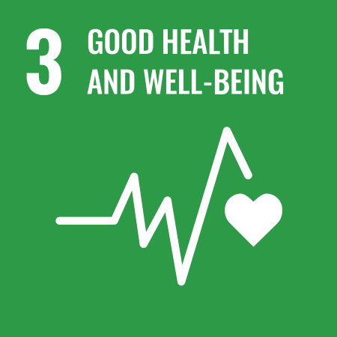 | 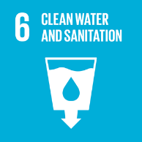 | 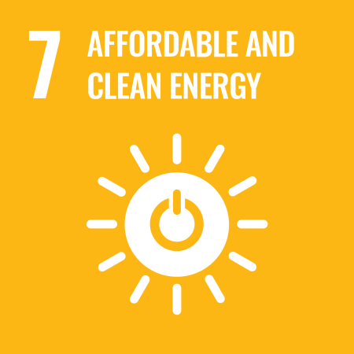 | 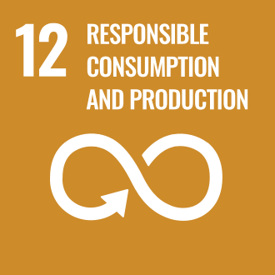 | 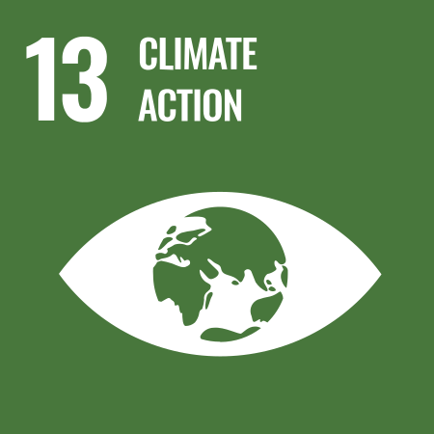 | 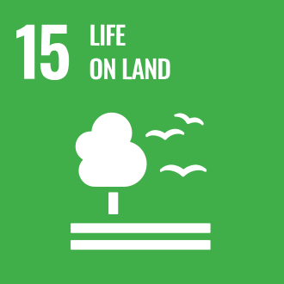

Review Mechanism
- Annual Performance Review:
- An annual performance review is conducted to assess progress towards sustainability goals and targets.
- Key achievements, challenges, and areas for improvement are identified through a comprehensive evaluation process.

- Continuous Improvement:
- Feedback from performance reviews, internal audits, and stakeholder engagement activities is used to identify opportunities for continuous improvement.
- Adjustments to strategies, policies, and action plans are made as necessary to enhance sustainability performance and address emerging issues.

- Policy Review and Update:
- The Chief Sustainability Officer reviews this policy annually to ensure alignment with changing regulatory requirements, industry best practices, and stakeholder expectations.
- Company can also change or review policy if any necessary changes is required.
- Updates to the policy are communicated internally, and relevant training is provided to ensure awareness and compliance.
Version | Date | Description of Changes | Approved By
1.0 | 01-01-2024 | Initial release of the Environmental Policy | Management
2.0 | 01-01-2026 | Added “Product End-of-Life” section including circular economy, recycling, reusable packaging, and post-consumer waste management commitments | Management

(Signature)
Approved By:
Designations:
Last Review Date: 01-01-2026 Next Review Date: 01-01-2031

Employee Acknowledgement Form: Environmental Policy

I acknowledge that I have received, read, and understood Arminak Solutions LLC dba KBL Cosmetics Environmental Policy. I am aware of the company's commitment to protecting the environment, promoting sustainable practices, and extending our eco-friendly mindset across the entire supply chain.
I understand my role in supporting this policy, including complying with all applicable environmental laws and regulations, participating in sustainability initiatives, and contributing to the company's environmental goals. I agree to adhere to sustainable practices in my daily work, report any environmental concerns, and contribute ideas for continuous improvement.
By signing below, I confirm my commitment to upholding Arminak Solutions LLC dba KBL Cosmetics Environmental Policy and supporting the company's sustainability efforts.

Employee Name: ______________________
Date: _______________
Employee Signature: ____________________

